COS 210

Worksheet 4

Scott Bebington

U21546216

**Question 1**

Prove that, if A is a regular language, then for all natural numbers k ≥ 0 the language Ak is also regular, using induction.

Base case: k=0

A^0 = ε, ε is a regular language since it can be accepted by the starting state of function if the starting state is an accepting state. Therefor the statement A^k is regular for k = 0.

Inductive step: k + 1

Assume that the language A^k is regular for some natural number k >= 0. We need to show that the language A^(k+1) is also regular.

To expand:

A^(k + 1) = A*A^(k)

Since regular languages are closed under concatenation, and A was given to be a regular language ,and A*A^k is a concatenation of A and A^k.

We can say that A^(k + 1) is also a regular language and that there exists a DFA such that the Language M=(Q, Σ, δ, q0, F) accepts A^(k + 1).

Therefore, using induction, we have shown that if A is a regular language, then for all natural numbers k >= 0, the language A^k is also regular,

**Question 2**

For the alphabet Σ = {a, b}, let A be the language such that

A = {w : w contains exactly one b and at least two a’s}.

A+ is the concatenation of A^k with k > 0

The NFA is as follows.

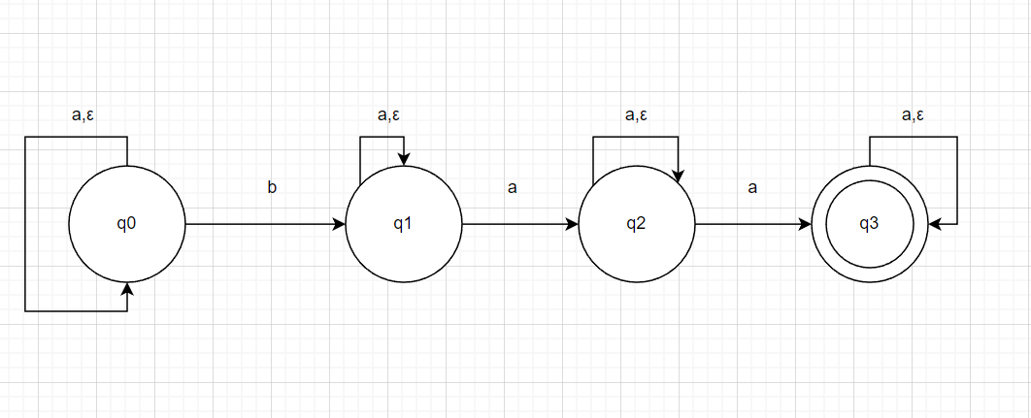

As you can see, no matter how many concatenations of A there are, the following state diagram holds, therefor A+ is also a regular language.

**Question 3**

For the alphabet Σ = {a, b} we define the language A as

A = {w : w contains exactly one b and at least two a’s}.

Give the regular expression describing this language.

a* (baa) a* U a* (aba) a* U a* (aab) a*

**Question 4**

For the alphabet {a, b, c} we define the language A as

A = {w : w contains the substring bac at least three times}.

Give the regular expression describing this language.

(a U b U c)* bac (a U b U c)* bac (a U b U c)* bac (a U b U c)*

**Question 5**

For the alphabet {a, b, c, d} we define the language A as

A = {w : every even position is a or b, every odd position is c or d}.

Give the regular expression describing this language.

(Take into account that a string w may have an even or an odd length.)

(c U d) U ((c U d) (a U b))* U ((c U d) ((a U b) (c U d))*)